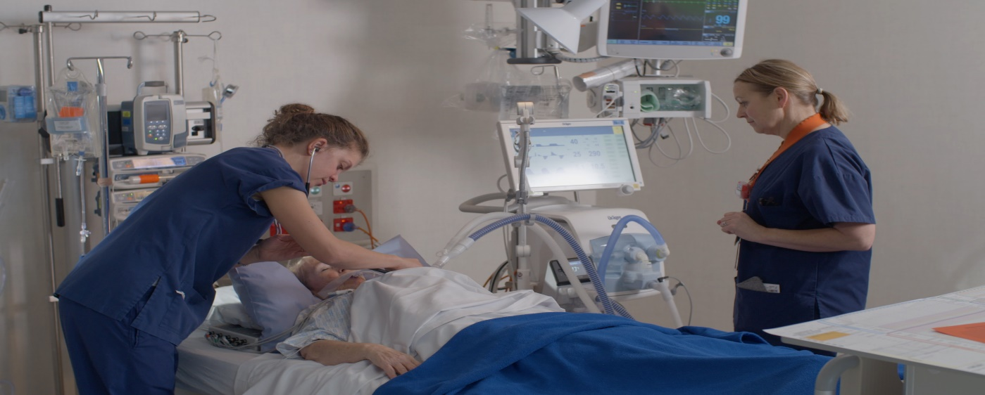

NZCCOF 2022

Thursday 24th  November , 2022

Venue – Manawa 276 Antigua Street, Level 3 Room 314

0830 – 1700 hours

Last Date for Registration 16th November 2022

|  |  |
| --- | --- |
| Personal Information | |
| **Surname** |  |
| **First Name** |  |
| **Preferred Name** |  |
| **Designation** |  |
| **Department** |  |
| **DHB** |  |
| **Email** |  |
| **Cell Phone** |  |
| **Emergency Contact Details** |  |
| **Other** | Tea, coffee, snacks and a light lunch will be supplied. |
| **Dietary** |  |
| **Disability Access** |  |

RSVP: [cathy.king@cdhb.health](mailto:cathy.king@cdhb.health).nz

Kindly sponsored by

